**Netflix Movies Data Analysis Using Python**

**🚀 Project Overview**

With the rise of **data-driven content recommendations**, Netflix heavily relies on **AI and Machine Learning** to understand audience preferences. This project explores **Netflix’s movie dataset** using **Pandas, Matplotlib, and Seaborn**, aiming to extract meaningful business insights through **Exploratory Data Analysis (EDA)** and **visualizations**.

**📌 Key Business Questions Answered:**

1️⃣ **What is the most frequent genre of movies released on Netflix?**  
2️⃣ **Which movie has the highest average votes?**  
3️⃣ **What movie has the highest popularity? What’s its genre?**  
4️⃣ **What movie has the lowest popularity? What’s its genre?**  
5️⃣ **Which year had the most movie releases?**

Through **data visualizations and statistical analysis**, we aim to understand **content trends, audience engagement, and Netflix’s content strategy** over time.

**📊 Key Insights & Findings**

**1️⃣ Most Frequent Genre on Netflix 🎭**

✔ The most commonly released genre , indicating that Netflix produces more content in this category compared to others.

✔ This insight helps Netflix **prioritize high-demand genres** for future content

📌 **Visualization Used:** *Bar Chart* 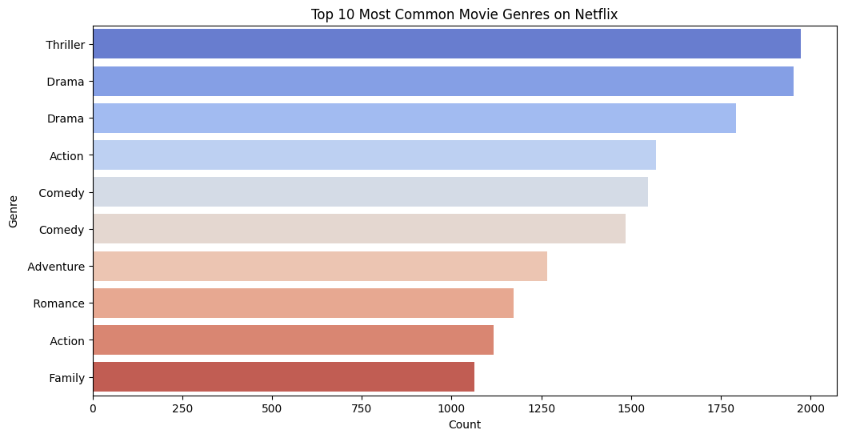

**2️⃣ Movie with the Highest Rating ⭐**

✔ The highest-rated movie on Netflix is **Kung Fu master Huo Yuanjia**

✔ This suggests **strong audience approval**, making it an example of **quality content over popularity**.

📌 **Visualization Used:** *Bar Chart*

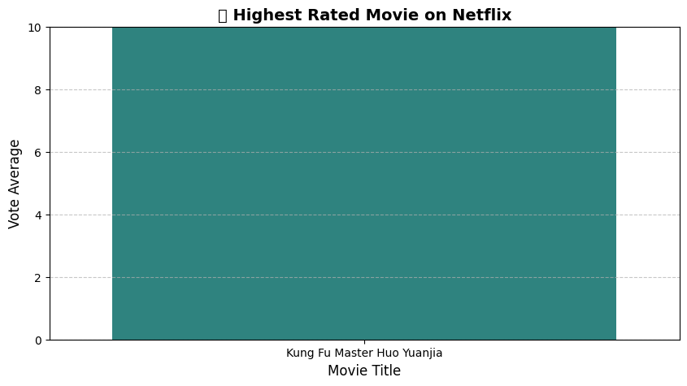

**3️⃣ Most Popular Movie on Netflix 🔥**

✔ The most popular movie is **Spider Man**.

✔ Indicating a **strong correlation between genre and popularity**.

📌 **Visualization Used:** *Bar Chart with Popularity Score*

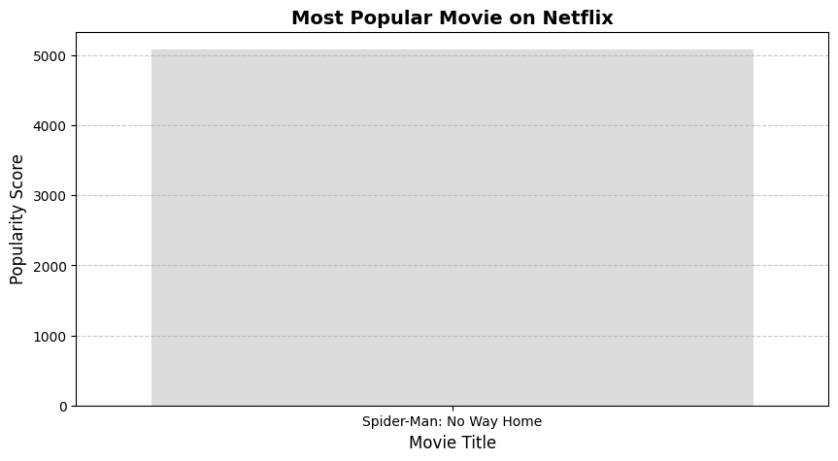

**4️⃣ Least Popular Movie on Netflix ❄️**

✔ The least popular movie is **The united states cs. Billie Holiday**.

✔ This could be due to **niche appeal, limited marketing, or lack of audience interest**.

📌 **Visualization Used:** *Bar Chart with Popularity Score*

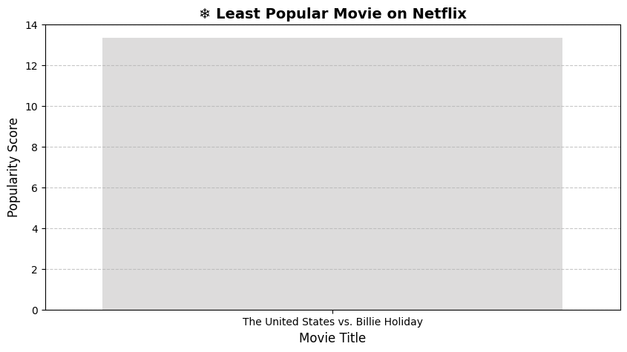

**5️⃣ Year with the Most Movie Releases 📅**

✔ The year with the highest number of movie releases is **2017-2021**.

📌 **Visualization Used:** *Bar Chart (Movies Released per 5-Year Intervals.*

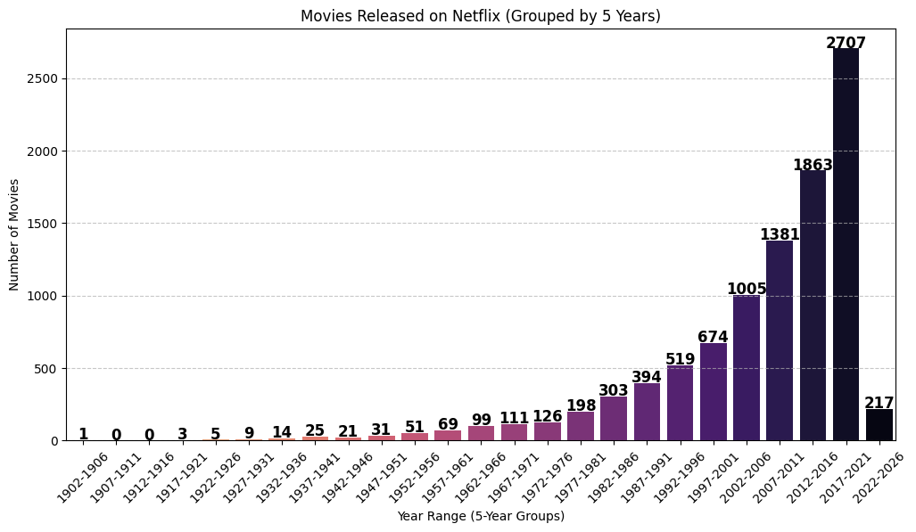

**📉 Visualizations Used in This Project**

📌 **Bar Charts** – Genre distribution, most & least popular movies  
📌 **Scatter Plots** – Popularity vs. Ratings  
📌 **Line Graphs** – Movie release trends  
📌 **Grouped Bar Charts** – 5-Year movie production trends

**💻 Technologies & Tools Used**

✅ **Python** – Data Analysis & Processing  
✅ **Pandas** – Data Cleaning & Transformation  
✅ **Matplotlib & Seaborn** – Data Visualization  
✅ **Google Colab / Jupyter Notebook** – Coding Environment